# **Country – French**

# **Croquembouche**



**Meal type – Desserts**

Serves – 12 person.

Cooks in 1 Hour 30 minutes.

*Ingredients*

* 100 g unsalted butter
* 1 teaspoon golden caster sugar
* 200 g plain flour
* 4 large free-range eggs
* 1 x 400 in or jar of dulce de leche (condensed milk caramel)
* 300 g golden granulated sugar
* OPTIONAL: CHOCOLATE SAUCE
* 100 g dark chocolate (70% solids)
* 300 ml single cream

*Method*

1. Preheat the oven to 200ºC/400ºF/gas 6.
2. Put the butter, sugar and 1 teaspoon of sea salt in a pan with 325ml of water. Bring to the boil.
3. Remove from the heat, add the flour and beat into a paste. Beat in the eggs, one by one, till smooth and combined.
4. Transfer the mixture to a piping bag fitted with a plain nozzle.
5. Pipe onto 2 large non-stick baking trays in dollops the size of large walnuts, leaving a gap between them so they can rise. You should get about 40.
6. Wet your finger and gently squash the peak on each so they don’t burn, then bake for 15 to 20 minutes, or until puffed and golden.
7. Remove from the oven and cool on a wire rack, then use a small sharp knife to pierce a little hole in each.
8. Wash out the piping bag and nozzle, then spoon in the dulce de leche. Pipe the buns with dulce de leche, until just full. It might take a little practice, so don’t worry if you mess up a couple. Persevere, it’s worth it.
9. If making the chocolate sauce, smash up the chocolate and place in a heatproof glass bowl with the cream and a pinch of salt.
10. Place over a pan of gently simmering water (make sure the water doesn’t touch the bowl), and leave until the chocolate is melted and glossy, stirring occasionally.
11. Make a toffee by adding the golden sugar to a shallow heavy-based non-stick pan with 50ml of water.
12. Place over a high heat and leave to bubble for 4 to 5 minutes, or until light brown and syrupy. Don’t stir it, just gently shake the pan occasionally, and be careful – hot sugar can burn very easily, so keep the kids away and don’t be tempted to taste it.
13. Leave the toffee for a few minutes to cool slightly, then, using tongs, carefully and lightly dip each bun into the toffee to get just a very thin coating (you don’t want to break your guests’ teeth) and practise sticking them together.
14. Once you’re happy, arrange the buns on a platter so they stick together and build upwards into a pyramid shape. Serve with chocolate sauce, if you like.

# **Country – Sri Lanka**

# **Monkfish curry**

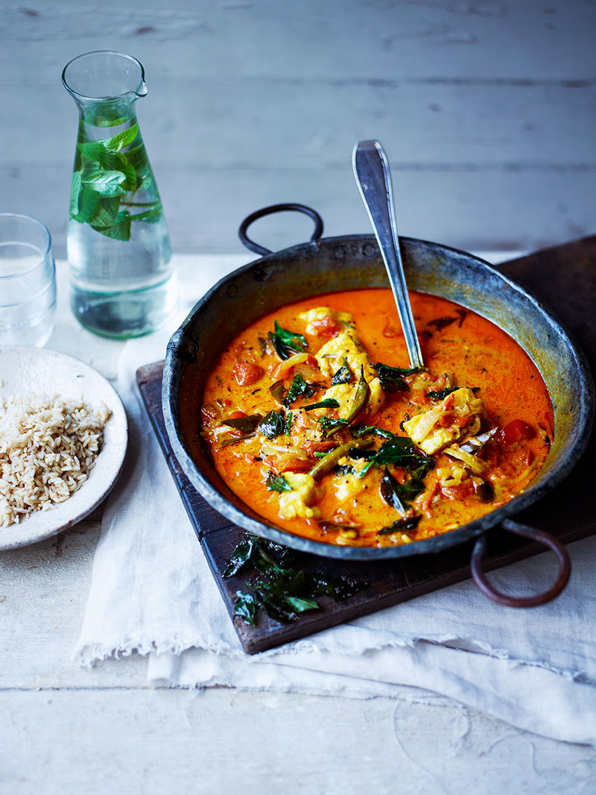

**Meal type – Lunch and Dinner**

Serves – 4 person.

Cooks in 55 minutes.

*Ingredients*

* 500 g monkfish , skinned, deboned (your fishmonger can do this for you), from sustainable sources
* 1 teaspoon ground turmeric
* 2 limes
* 200 g brown rice
* 1 x 400 ml tin of light coconut milk
* SAUCE
* 2 onions
* 2 cloves of garlic
* 5cm piece of ginger
* 2 fresh green chillies
* 10 ripe medium tomatoes, on the vine
* groundnut oil
* 1 small handful of fresh curry leaves
* 3 cardamom pods
* 2 teaspoons brown mustard seeds
* 1 teaspoon cumin seeds
* 1 teaspoon fenugreek seeds
* ½ teaspoon ground turmeric
* 1 knob of tamarind paste or 1 teaspoon tamarind syrup

*Method*

1. Slice the monkfish into large chunks and pop in a non-reactive bowl, along with the turmeric, lime zest and juice and a large pinch of sea salt.
2. Mix together to coat the fish, then leave in the fridge for at least 1 hour.
3. Add the rice to a pan with 100ml of the coconut milk and 300ml of salted water, then cook according to the packet instructions.
4. To make your sauce, peel and finely slice the onions and garlic, peel and finely chop the ginger, then slice the chillies. Roughly chop the tomatoes, keeping them separate.
5. Heat a large casserole pan over a medium–high heat and add a splash of oil, the onion, ginger, garlic, chillies and curry leaves. Cook for 5 to 10 minutes, or until the onion is softened and coloured.
6. Smash the cardamom pods in a pestle and mortar, then stir them into the pan along with the mustard seeds, cumin, fenugreek and turmeric. Fry for 1 minute.
7. Stir in the chopped tomatoes, tamarind paste or syrup, the remaining 300ml of coconut milk and 100ml of water, then simmer for 10 minutes, or until the tomatoes begin to break down and the sauce reduces.
8. Add the monkfish to the sauce and simmer until the fish is cooked through and opaque. Remove and discard the cardamom pods, then serve with the rice on the side.

# **Country – Thailand**

# **Vegetable broth**

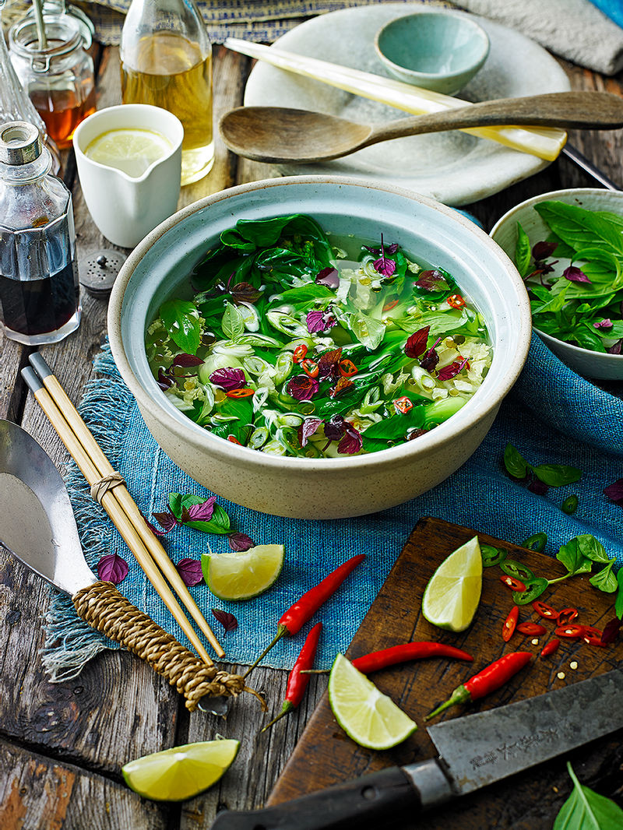

**Meal type – Starters**

Serves – 2 person.

Cooks in 45 minutes.

*Ingredients*

* 3 cloves of garlic
* 5cm piece of ginger
* 200 g mixed Asian greens , such as baby pak choi, choy sum, Chinese cabbage
* 2 spring onions
* 1 fresh red chilli
* 5 sprigs of fresh Thai basil
* 1 stick of lemongrass
* 2 star anise
* 800 ml clear organic vegetable stock
* 1 teaspoon fish sauce , (optional)
* 1 teaspooon soy sauce
* 1 small punnet shiso cress
* 1 lime

*Method*

1. Peel and crush the garlic, then peel and roughly chop the ginger. Trim the greens, finely shredding the cabbage, if using. Trim and finely slice the spring onions and chilli. Pick the herbs.
2. Bash the lemongrass on a chopping board with a rolling pin until it breaks open, then add to a large saucepan along with the garlic, ginger and star anise.
3. Place the pan over a high heat, then pour in the vegetable stock. Bring it just to the boil, then turn down very low and gently simmer for 30 minutes.
4. A couple of minutes before it’s cooked, throw in your Asian veggies and gently cook until they are wilted but still crunchy.
5. Serve the broth in deep bowls seasoned with fish sauce (if using) and soy sauce, sprinkle with the herbs, cress, spring onion and chilli, then serve with wedges of lime.

# **Country – South Korea**

# **Kimchi**

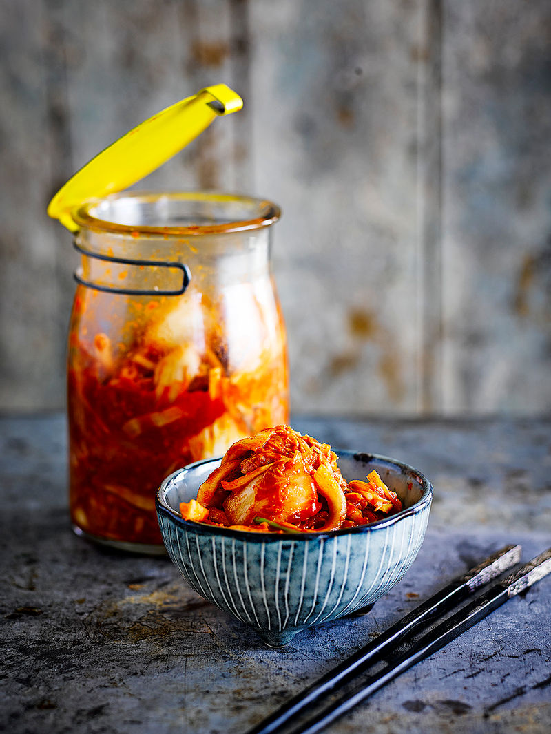

**Meal type – Sides**

Serves – 8 person.

Cooks in 3 Hours 5 minutes.

*Ingredients*

* 1 Chinese cabbage
* 6 cloves of garlic
* 1 thumb-sized piece of ginger
* 2 teaspoons caster sugar
* 2 tablespoons Korean shrimp paste
* 2 tablespoons dried gochugaru , (see tip)
* 200 g daikon , (see tip)
* 6 spring onions

## *Method*

1. Quarter and remove the stalks from the cabbage, then chop it into 4cm pieces and place in a large bowl. Sprinkle over 4 tablespoons of sea salt and massage it in with your hands.
2. Cover the cabbage with cold water and sit a plate on top to keep the veg submerged. Set aside for 2 hours.
3. Tip the cabbage into a colander, rinse it thoroughly under cold water, then leave to drain for 30 minutes.
4. Peel the garlic and ginger, then place in a food processor with the sugar and blitz to a smooth paste. Transfer it to a bowl and mix in the shrimp paste and gochugaru until combined.
5. Matchstick the daikon and spring onions, then place in a large bowl.
6. Squeeze out any excess water from the cabbage, then add it to the bowl, along with the gochugaru paste. Wearing disposable gloves, use your hands to mix it all together thoroughly.
7. Spoon the kimchi into a large kilner jar and press it down so the juices rise, leaving a gap at the top, then close and seal the lid.
8. Leave the kimchi to ferment at room temperature for 2 to 5 days (place the jar on a plate to catch any brine that might bubble over.) Check the kimchi every day, letting out some gas and pressing the vegetables down into the brine.
9. When the kimchi tastes delicious, transfer the jar to the fridge for up to 3 months.

#### **Tips**

*Gochugaru is Korean red pepper powder. Daikon is a white radish, also called mooli, and can be found at Asian grocers.*

**Country – Japan**

# **Tofu & cashew stir-fry**

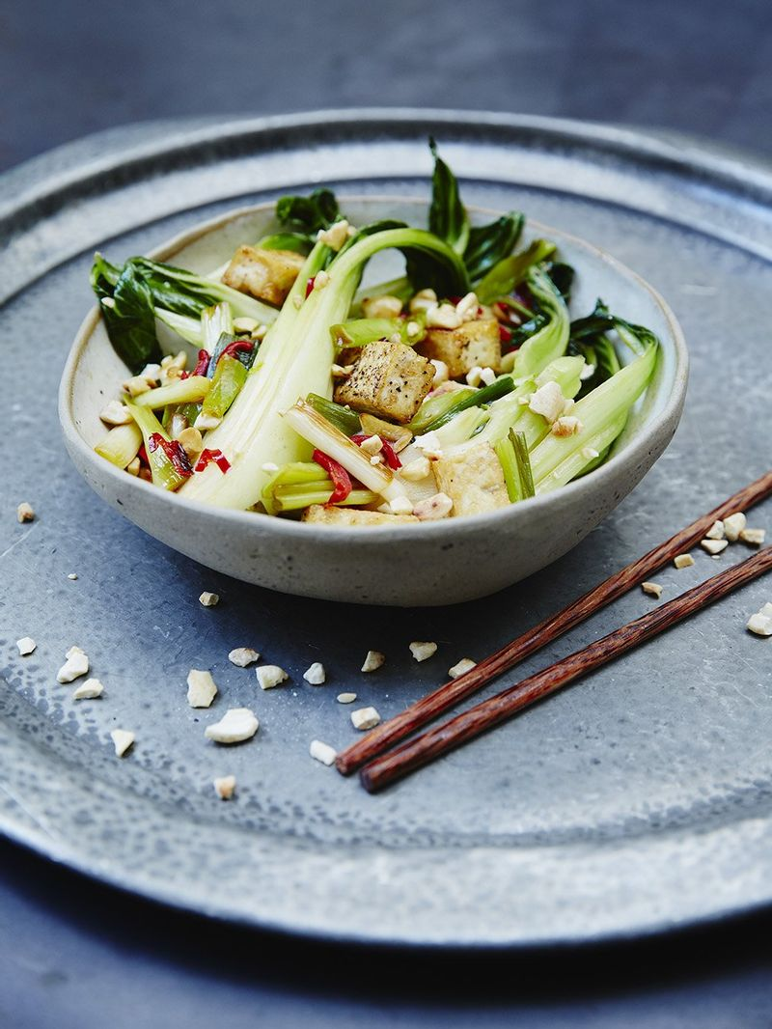

**Meal type – Sides**

Serves – 2 person.

Cooks in 35 minutes.

*Ingredients*

* 350 g firm tofu
* groundnut oil
* 40 g cashew nuts
* 5 cloves of garlic
* 1-2 fresh red chillies
* 2 pak choy
* 6 spring onions
* 2 tablespoons mirin or dry sherry
* 2 tablespoons low-salt soy sauce
* 1 tablespoon runny honey
* 1 tablespoon sesame oil
* 2 teaspoons rice wine vinegar

*Method*

1. Slice the tofu into rectangular, bite-sized chunks. Drain and pat dry with kitchen paper to get rid of any excess moisture, then season with a good pinch of sea salt and freshly ground black pepper.
2. Heat 1cm of groundnut oil in a large wok over a medium heat. Drop a small piece of tofu into the hot oil – if it sizzles and turns golden, it’s ready to go. Add the tofu in batches and fry for 5 to 8 minutes, or until golden, turning regularly.
3. Meanwhile, toast the cashew nuts in a dry frying pan for 1 to 2 minutes, or until golden. Tip into a pestle and mortar and crush lightly. Peel the garlic and deseed the chillies, then finely slice. Slice the pak choy lengthways into quarters, then halve each piece lengthways again. Trim and slice the spring onions into 2cm pieces.
4. Once golden, use a slotted spoon to remove the tofu to a double layer of kitchen paper to drain. Carefully remove and discard most of the oil, leaving about 1 tablespoon in the pan, then return to a medium-high heat. Add the garlic and chilli and fry for 1 minute, or until lightly golden, then add the pak choy and spring onions. Fry for a further 3 to 4 minutes, or until softened slightly. Stir in the mirin, soy sauce, honey, sesame oil and vinegar for 1 minute and give it another good stir. Throw in the cashews and fried tofu, toss well for a minute to warm through, then serve straightaway.

# **Country – Vietnam**

# **Bun cha with sticky spicy tofu**

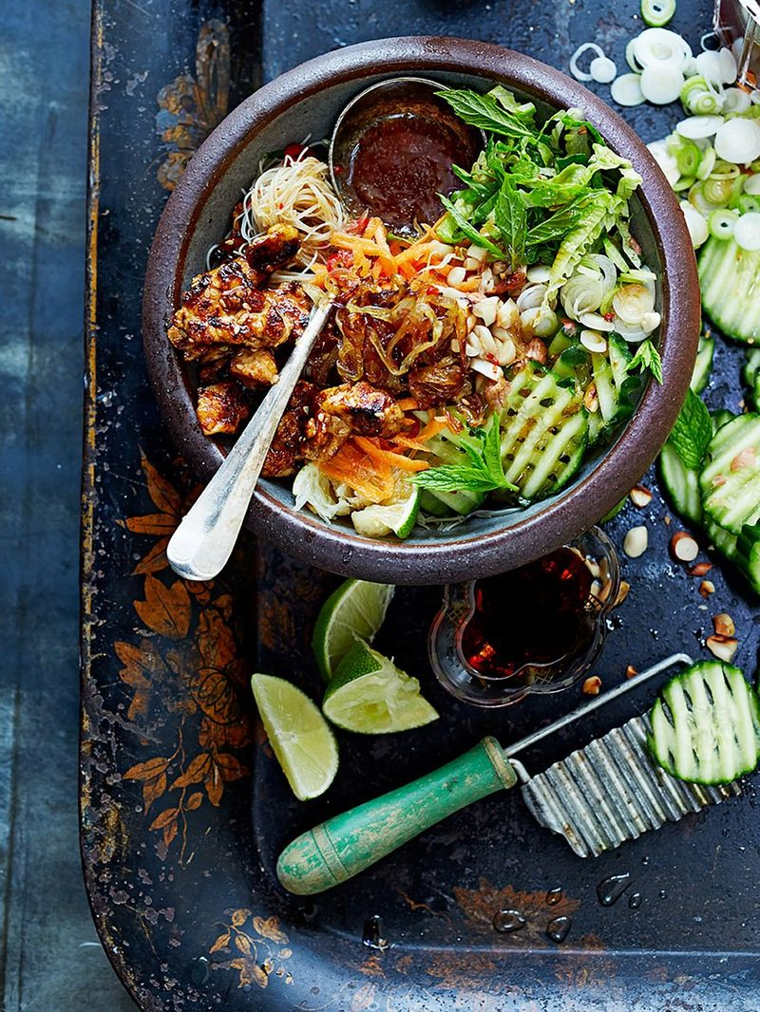

**Meal type – Starters**

Serves – 4 person.

Cooks in 45 minutes

*Ingredients*

* sesame oil
* 1 large brown onion
* 350 g pack of firm tofu
* 6 tbsp hoisin sauce
* 2 tbsp sesame seeds
* 250 g thin brown rice noodles
* a small handful of peanuts
* 1 long red chilli
* 2 limes
* chilli sauce , to serve
* DRESSING
* 3 tbsp brown sugar
* 1 stick of lemongrass
* 3 tbsp reduced-salt soy sauce
* 1 tbsp white wine vinegar
* 1 tbsp toasted sesame oil , plus extra to serve
* 2 limes
* SALAD
* 2 carrots
* 1/2 cucumber
* 2 baby gem lettuce
* 4 spring onions
* 1 small bunch of mint

*Method*

1. Make the dressing first, so that all the flavours have time to mingle. In a large bowl or measuring jug, dissolve the sugar in 50ml of boiling water.
2. Remove and discard the tough outer layers of the lemongrass and finely chop. Stir through all the other ingredients and squeeze in the lime juice, then set aside.
3. Peel and thinly slice the onion. Heat a little sesame oil in a frying pan and fry the onion over a low-medium heat, until soft and golden at the edges, about 10 minutes. Set aside.
4. Drain the tofu and break into very rough chunks. In the same pan, heat 2 tablespoons of the sesame oil over a medium heat, then add the tofu and fry until it starts to go crispy on the edges – about 5 minutes.
5. Stir in the hoisin sauce and keep it on the heat for about 3 minutes, until it’s sweet and sticky and coats all the tofu. Add the sesame seeds for the final minute, then it’s done.
6. Soak the noodles in boiling water until soft, then drain.
7. For the salad, grate the carrot and cucumber (or use a crinkle cutter). Finely slice the baby gem and spring onions. Pick the mint leaves. Combine all the salad ingredients in a bowl and set aside.
8. Crush the peanuts, finely slice the chilli and cut the lime into wedges.
9. To assemble your meal, divide the noodles between serving bowls, followed by the salad, then the tofu and onion, scatter over the peanuts and chilli and generously share out the dressing. Serve with extra toasted sesame oil, lime wedges and chilli sauce.



# **Country – Welsh**

# **Classic crumpets**



**Meal type – Breakfast**

Serves – 6 person.

Cooks in 50 minutes

*Ingredients*

* 400 ml milk
* 1 tablespoon dried yeast
* 1 teaspoon caster sugar
* 300 g strong white flour
* ½ teaspoon bicarbonate of soda
* vegetable oil , for greasing
* HOMEMADE BUTTER
* 350 ml double cream

*Method*

1. Gently warm the milk. In a bowl, dissolve the yeast and sugar in the warm milk and 100ml of tepid water. Leave in a warm place for 15 minutes, or until frothy.
2. Sift the flour, bicarbonate of soda and 1 teaspoon of fine sea salt into a large bowl. Make a well in the centre and pour in the yeast mixture.
3. Whisk from the centre outwards until the consistency of double cream – this will take a few minutes. Add a splash more water, if needed.
4. Cover with a damp tea towel and set aside for 45 minutes or until little bubbles form on the surface.
5. For the butter, pour the cream into a freestanding mixer. Whisk on high for 5 to 10 minutes, or until the cream splits into solids and liquid.
6. Drain through a sieve, discard the liquid, then rinse the solids thoroughly with cold water. Place in muslin and squeeze out any excess liquid. Mix ½ a teaspoon of sea salt through and wrap in greaseproof paper.
7. Grease four 10cm egg rings with vegetable oil. Wipe a little oil around a large frying pan or iron skillet and place over a medium-high heat.
8. Arrange the rings in the frying pan and, once hot, spoon 4 tablespoons of the batter into each ring. Cook for 5 minutes, or until little bubbles appear on the surface.
9. Once the bubbles have burst, leaving little holes, use tongs to carefully lift off the rings and flip over the crumpets, then cook for 1 minute on the other side. Re-grease and reheat the rings and pan before cooking the next batch.
10. Serve the crumpets warm, with a slather of butter. If making them in advance, just toast lightly on both sides when you come to serve them.

**Country - Egypt**

# **Beef tagine**

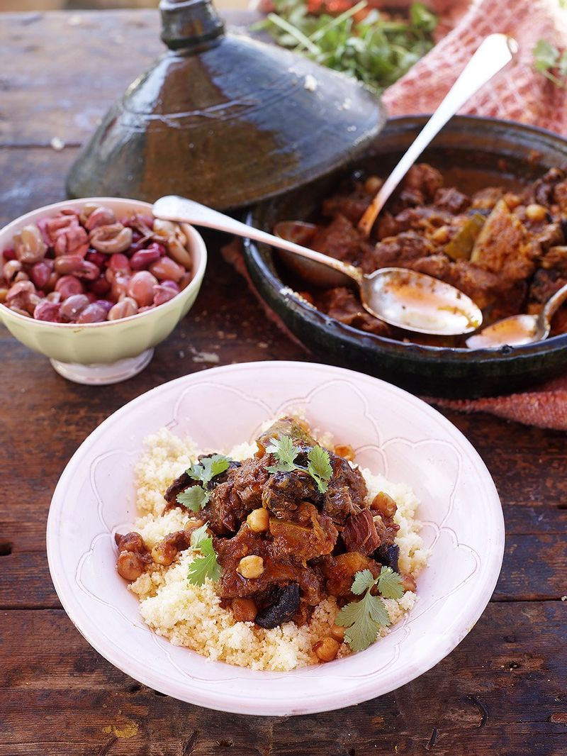

**Meal type – Lunch and Dinner**

Serves – 8 person.

Cooks in 3 Hours 5 minutes

*Ingredients*

* 600 g stewing beef
* 1 onion
* ½ a bunch of fresh coriander
* olive oil
* 1 x 400 g tin of chickpeas
* 1 x 400 g tin of plum tomatoes
* 800 ml organic vegetable stock
* 800 g butternut squash
* 100 g prunes
* 2 tablespoons flaked almonds
* SPICE RUB
* 1 level tablespoon ras el hanout spice mix
* 1 level tablespoon ground cumin
* 1 level tablespoon ground cinnamon
* 1 level tablespoon ground ginger
* 1 level tablespoon sweet paprika

*Method*

1. Mix all the spice rub ingredients together in a small bowl with a good pinch of sea salt and black pepper.
2. Put the beef into a large bowl, massage it with the spice rub, then cover with clingfilm and place in the fridge for a couple of hours, preferably overnight.
3. When you’re ready to cook, peel and finely chop the onion, and pick the coriander leaves, finely chopping the stalks.
4. Heat a generous lug of oil in a tagine or casserole pan over a medium heat, add the meat and fry for 5 minutes to seal. Add the onion and coriander stalks and fry for a further 5 minutes.
5. Drain and tip in the chickpeas, followed by the tomatoes, breaking them up with a spoon, then pour in 400ml of stock and stir well. Bring to the boil, then cover and reduce to a low heat for 1½ hours.
6. Meanwhile, deseed and chop the squash into 5cm chunks, then destone and roughly tear the prunes. Toast the almonds in a dry frying pan until lightly golden, then tip into a bowl.
7. When the time's up, add the squash, prunes and remaining stock. Give everything a gentle stir, then pop the lid back on and continue cooking for another 1½ hours. Keep an eye on it, adding splashes of water, if needed.
8. At this stage, remove the lid and check the consistency. If it seems a bit too runny, simmer for 5 to 10 minutes, more with the lid off – the beef should be really tender and flaking apart now, so have a taste and season to taste.
9. Scatter the coriander leaves over the tagine along with the toasted almonds. Serve with a big bowl of lightly seasoned couscous and dive in.

**Country – Ireland**

# **Irish mackerel breakfast**

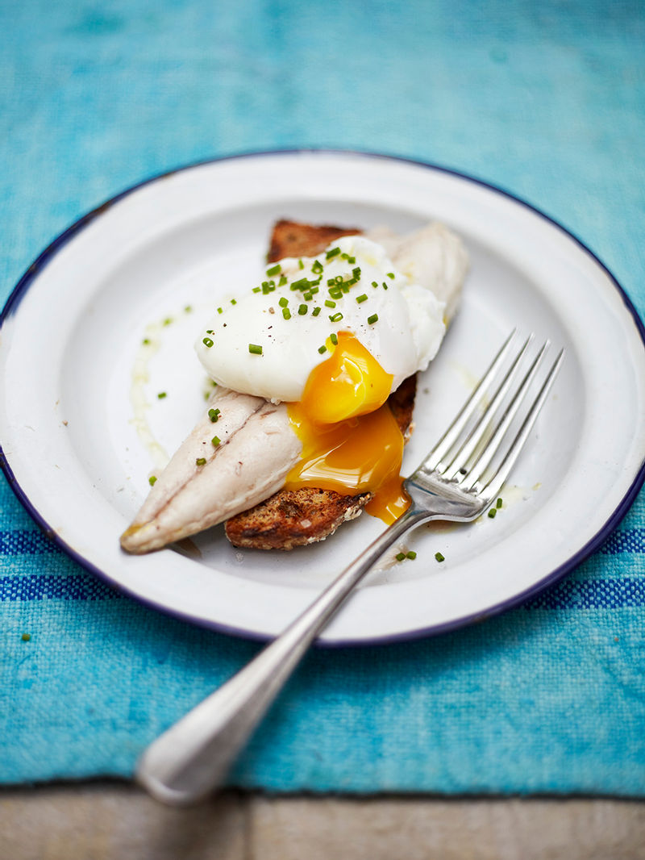

**Meal type – Breakfast**

Serves – 2 person.

Cooks in 20 minutes

*Ingredients*

* 2 fillets of mackerel, from sustainable sources
* 2 large free-range eggs
* 2 large slices of soda bread
* extra-virgin olive oil
* red wine vinegar
* a few fresh chives

*Method*

* Bring 2 pans of salted water to the boil and preheat your grill.
* Place your mackerel fillets in 1 pan and poach for 4 to 6 minutes, or until just cooked.
* Poach the eggs in the other pan for 3 minutes for a slightly runny yolk, or to your liking.
* Toast the soda bread, then drizzle with a little oil.
* Place on a plate and top with the mackerel, a splash of vinegar and a poached egg. Season well, then finely chop and sprinkle with chopped chives.

# **Country – Malaysia**

# **Malaysian whole fish**

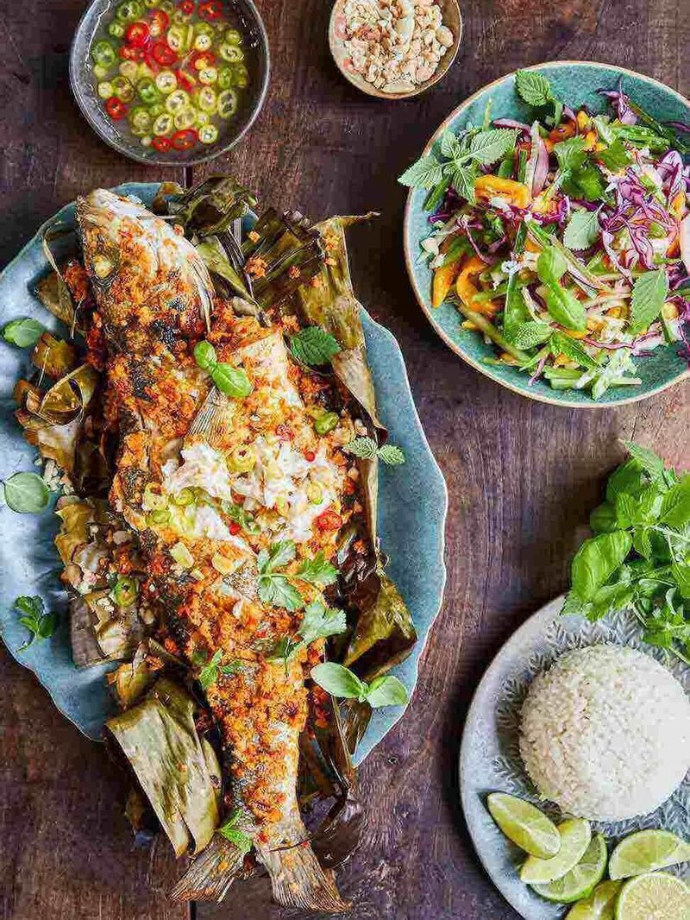

**Meal type – Starters**

Serves – 4 person.

Cooks in 1 hour 45 minutes

*Ingredients*

* 1 stick of lemongrass
* 1 shallot
* 5 cm piece of ginger
* 3 fresh red chillies
* 6 lime leaves , (fresh or dried)
* 100 g unsalted peanuts
* 1 tablespoon tomato purée
* 2 tablespoons fish sauce
* 1 lime
* 1 x 800 g whole sea bass , scaled, gutted, from sustainable sources
* 1 large banana leaf , optional
* 1 tablespoon low-salt soy sauce
* PICKLE
* 3 mixed-colour chillies
* 1 pinch of sugar
* 2 tablespoons white wine vinegar
* SALAD
* 1 fresh coconut
* 75 g sugar snap peas
* 75 g mangetout
* ¼ of a Chinese cabbage
* ¼ of a red cabbage
* ¼ of a cucumber
* 1 ripe mango
* ½ a bunch of fresh mint , (15g)
* ½ a bunch of fresh coriander , (15g)
* ½ a bunch of fresh basil , (15g)
* 1 lime
* COCONUT RICE
* 2 tablespoons vegetable oil
* 1 tablespoon creamed coconut
* 1 lime
* 1 mug of jasmine rice

*Method*

1. Preheat the oven to 220°C/425°F/gas 7.
2. Whack the lemongrass against your work surface and remove the tough outer layer. Peel the shallot and ginger, deseed the chillies, then roughly chop everything with the lemongrass. Add to a large pestle and mortar with a good pinch of sea salt and the lime leaves (discard the stalks) and pound to a paste.
3. Toast the peanuts in a large frying pan over a medium heat for 3 minutes, or until golden, then bash half into the paste. Add the tomato purée and fish sauce, finely grate in the lime zest and squeeze in all the juice, then muddle together.
4. With a sharp knife, score the sea bass skin at 1cm intervals in a criss-cross fashion, then rub all over with the paste, both inside and out.
5. Get your banana leaf (if using), or tear off a piece of baking paper five times as long as the fish and fold it in half to give you double thickness. Place the fish in the middle, then fold over to seal the fish snuggly inside. Place on a large baking tray and roast for 25 minutes, or until the flesh is succulent and comes away easily from the bone.
6. To make the rice, drizzle the vegetable oil into a saucepan over a medium heat. Crumble in the creamed coconut, then squeeze in the lime juice, throwing in the squeezed lime halves. Tip in the rice and fry for 2 minutes, then pour over 1 mug of boiling water and turn down the heat to low. Cover and cook for 12 minutes, then remove from the heat and allow to steam for a further 3 minutes.
7. For the chilli pickle, finely slice the chillies and place in a small bowl with the sugar, vinegar and a pinch of salt, then mix together and leave aside.
8. Now make the salad. Crack open the coconut and finely grate 50g of flesh into a serving bowl. Halve the sugar snaps and mangetout, finely shred both cabbages and cucumber, then peel and finely slice the mango and add it all to the bowl. Pick in most of the herb leaves, squeeze over the lime juice and toss together.
9. Pop the fish on a serving platter. Roughly crush the remaining peanuts in a pestle and mortar, then scatter over the salad and the fish. Drizzle the fish with the soy sauce and scatter over the remaining salad herbs.
10. Take the fish, chilli pickle, rice and salad to the table and let everyone help themselves.